

NAME :- Manav Gaur

College Roll NO :- 20231482

Examination Roll no:- 23020570020

SUBJECT :- Computer Networks

Submitted TO :- Ms.Sheetal Singh

1. To study basic network command and network configuration commands

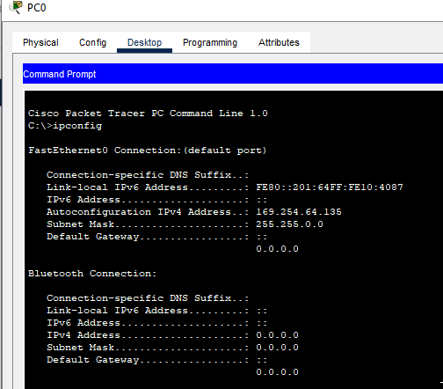

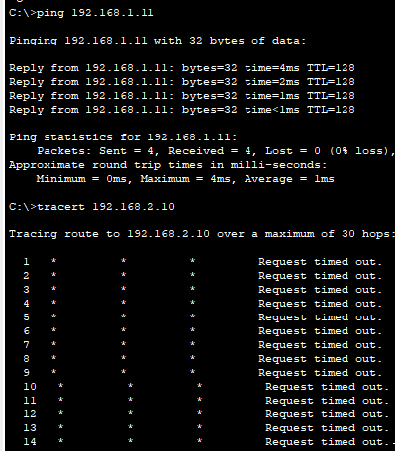

2. To study and perform PC to PC communication using ethernet

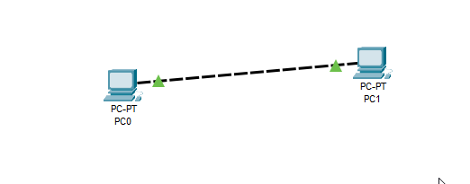

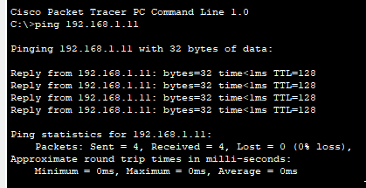

3. To create Star topology using hub and switch

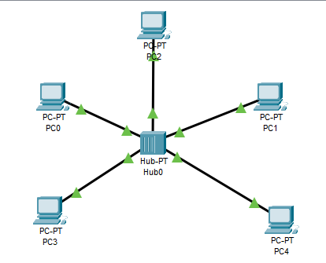

4. To create Bus, Ring, Tree, Hybrid, Mesh topologies

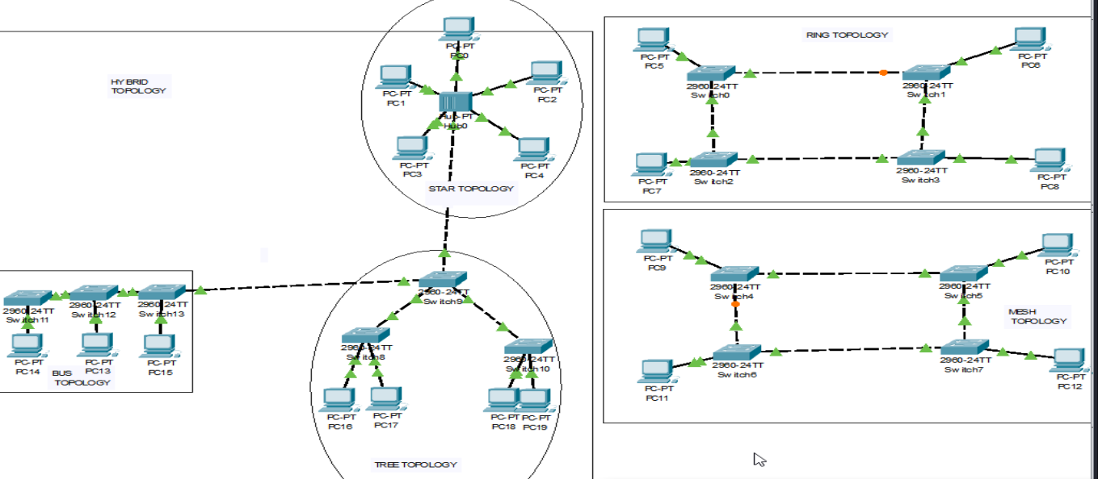

5. Perform an initial Switch configuration

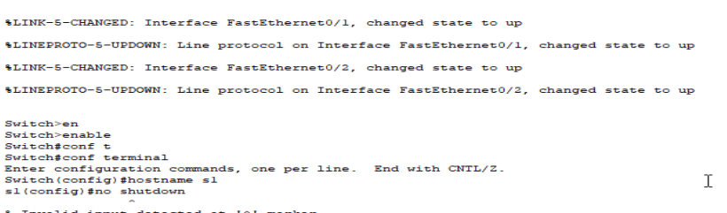

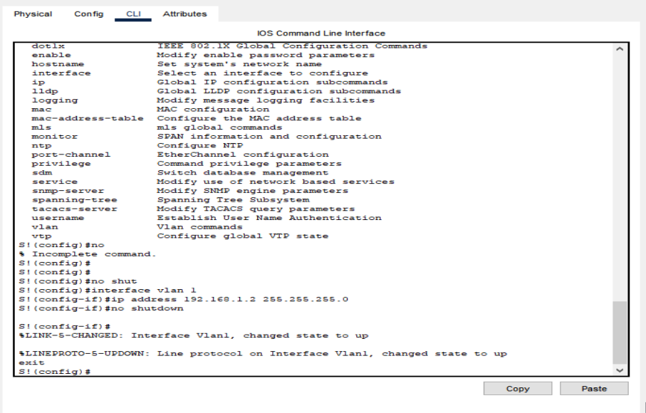

6. Perform an initial Router configuration

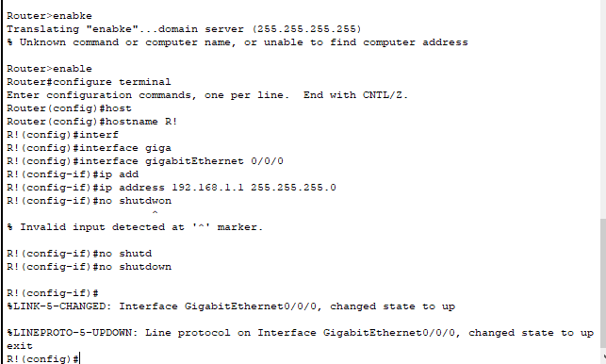

7. To implement Client Server Network

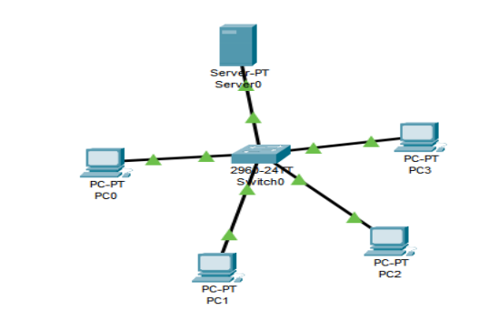

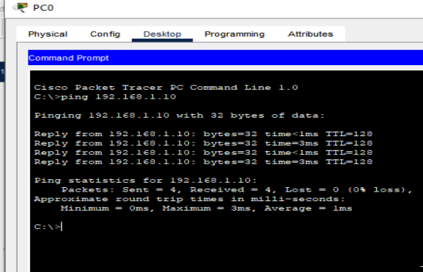

8. To implement connection between devices using router

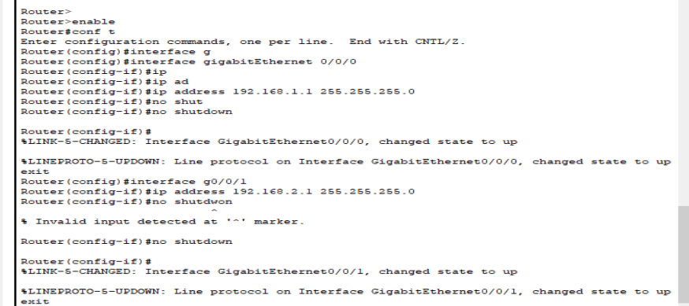

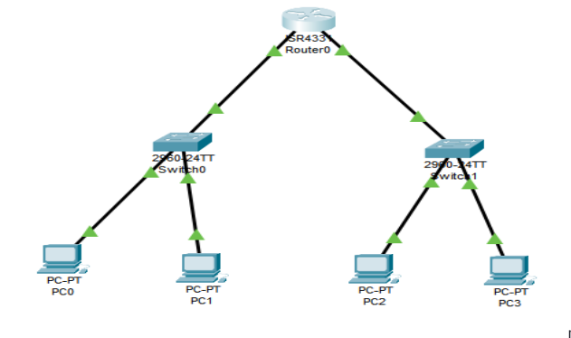

9. To perform remote desktop sharing within LAN connection

